

C++ 2

Assignment 1

Part 1

#Game

7208

Steven Sriwi

Contents

1 Overview 2

1.1 Objective 2

1.2 Reward of Objective Completion 2

1.3 Consequences of Objective Failure 2

1.4 Challenges for Players 2

2 Reason to Develop this Game 2

3 GUI 3

3.1 Welcome Screen 3

3.2 Instruction Screen 4

3.3 Main game Screen 4

3.4 Result Screen 5

3.4.1 Win Screen 5

3.4.2 Lose Screen 6

4 Classes 6

4.1 C.instruction 6

4.2 C.Result 6

4.3 C.No 6

5 Sequence Diagram 7

6 Project Plan 7

7 Milestone 7

8 Game Flowchart 8

# Overview

## Objective

The purpose of this basic game program is basically to provide a simple fun experience to people who plays it. This game will need users to sum 4 random digits together in the first stage and provide or guess the last digit of the whole number that has been added together. The length of this game will be 60 seconds and after that period of time, the game will end with an outcome according to the performance of the user. For example, If the console gave a random number of 92746, you will need to add every single digit that is displayed. In this example the answer is going to be 28, but you will need to key in the last digit which is “8” to the console.

## Reward of Objective Completion

Users will be given 60 seconds of time to finish one game. Where they will be given 3 lives to play this game. If users finished every stage without using all of their lives, then they will be granted “Champion”.

## Consequences of Objective Failure

However, if users used all their life before the time runs out (to lose a live, you will need to make one mistake), users will be prompted to a “Game Over” Page. If users never get to finish the whole stages within 60 seconds, users will get a high-score and “Almost there, Try again” Text.

## Challenges for Players

After completing the first stage the users will be directed to the second stage which will be 5 digits of number and as users solved each stage, users will be prompted to go the next stage and so on. Furthermore, users can only have 60s to reach to stage 20. After 60 seconds is up, then a high score message will pop up according to what they have best achieved in this simple game.

# Reason to Develop this Game

Inspired by a game that me and my father used to play 10 years ago, we used to play this game every time we are driving to a destination, basically we calculated every plate numbers of other car and provide the answer and the one who gets the answer first correctly will earn a point. Now, the game has been modified to a better and more complex game. This game reminds me of my parents and I would like to share this opportunity to experience how fun it is to play this game.

Furthermore, As I am still learning how to be a professional coder, I believe this game will increase my ability to be attentive to more complex coding skills using Classes and Random numbers functions.

# GUI

## Welcome Screen

When the program has been execute, users will be taken to a main menu execution screen. After doing so, users can choose either Play Game, Instructions or Quit the program. When users choose the first option, users can start the game with 60 second given to finish the game. Moreover, if users chooses option 2, then a instruction page will come out, where all the instructions will be shown on that page. However, if the users chooses the last option, the game will automatically close.

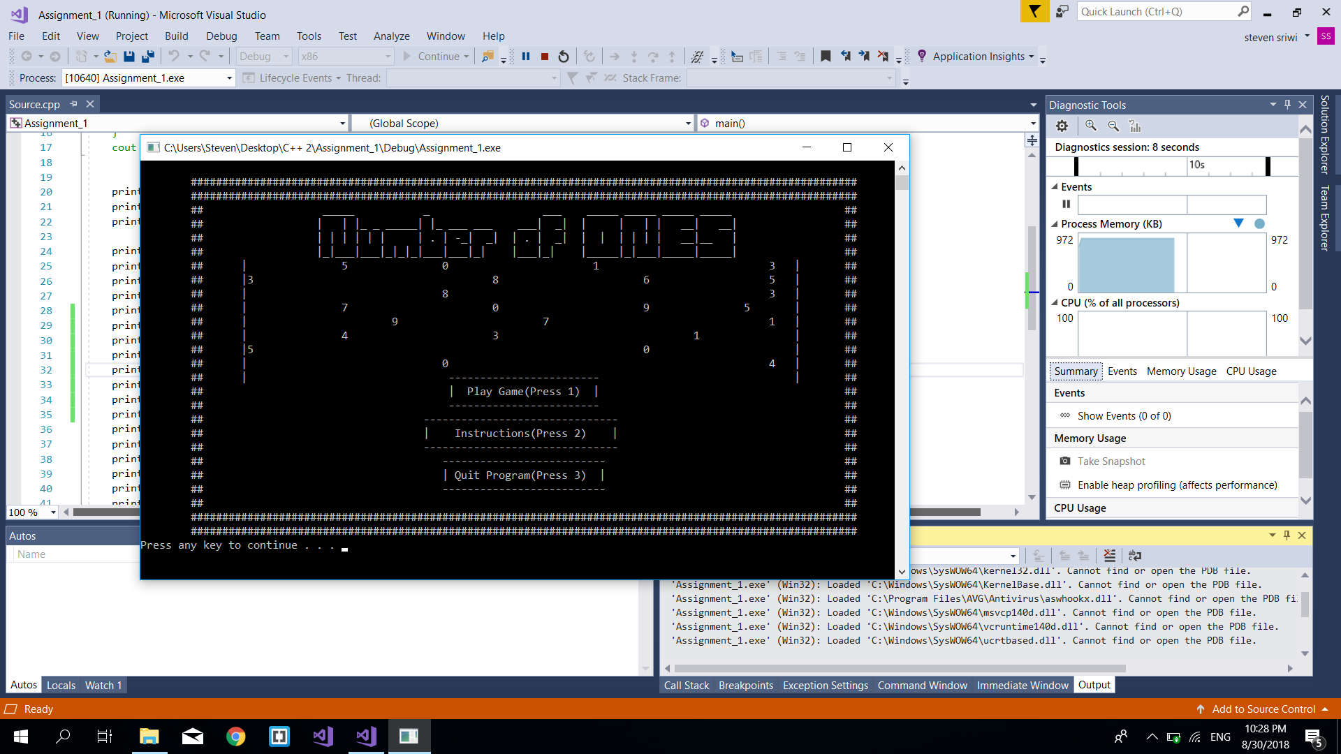

## Instruction Screen

Shown below is the prototype of the actual Instruction page of the game. Rules will be noted down to the page and instructions will be shown to play the game.

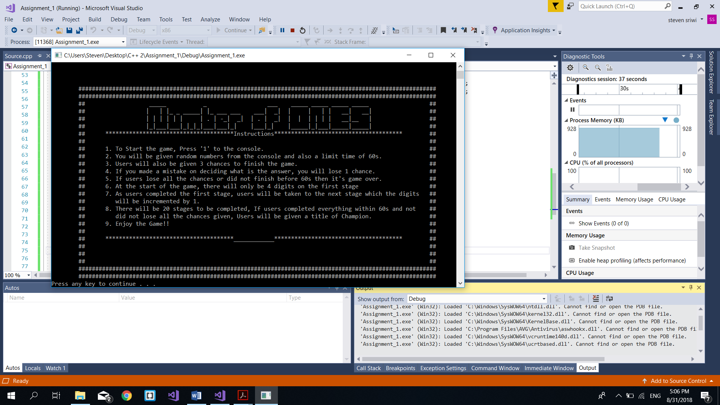

## Main game Screen

Shown below will be the sample of the game play, where console will give random numbers and users will need to guess what the answer and key in towards the console.

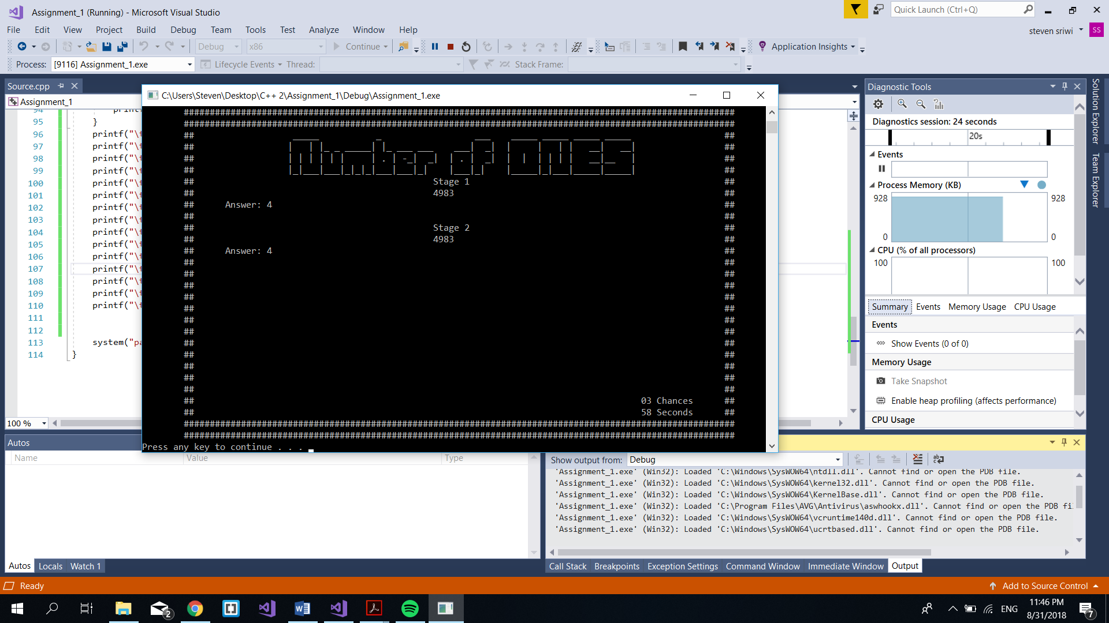

## Result Screen

### Win Screen

Shown below will be the result when you have completed all of the stages within the period of time given and without losing all the chances given. Console will generate “Champion “ word and also a retry playing key.

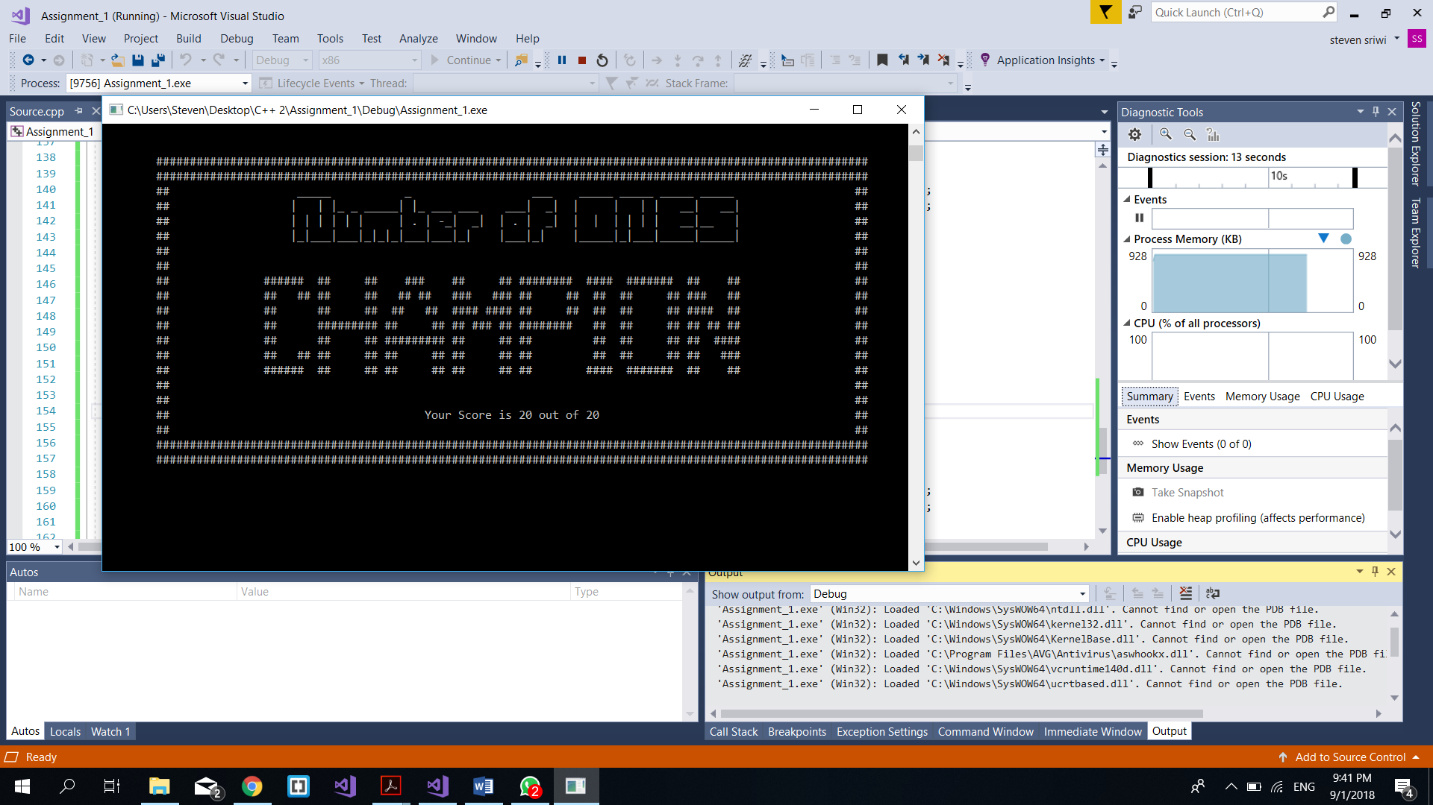

### Lose Screen

This result will come out when users has not finished all the stages within the period time given or have used all the chances that was given to the users. “Game Over” will be shown to the users through the console. However, a high-score will be displayed on the console according on how they perform best.

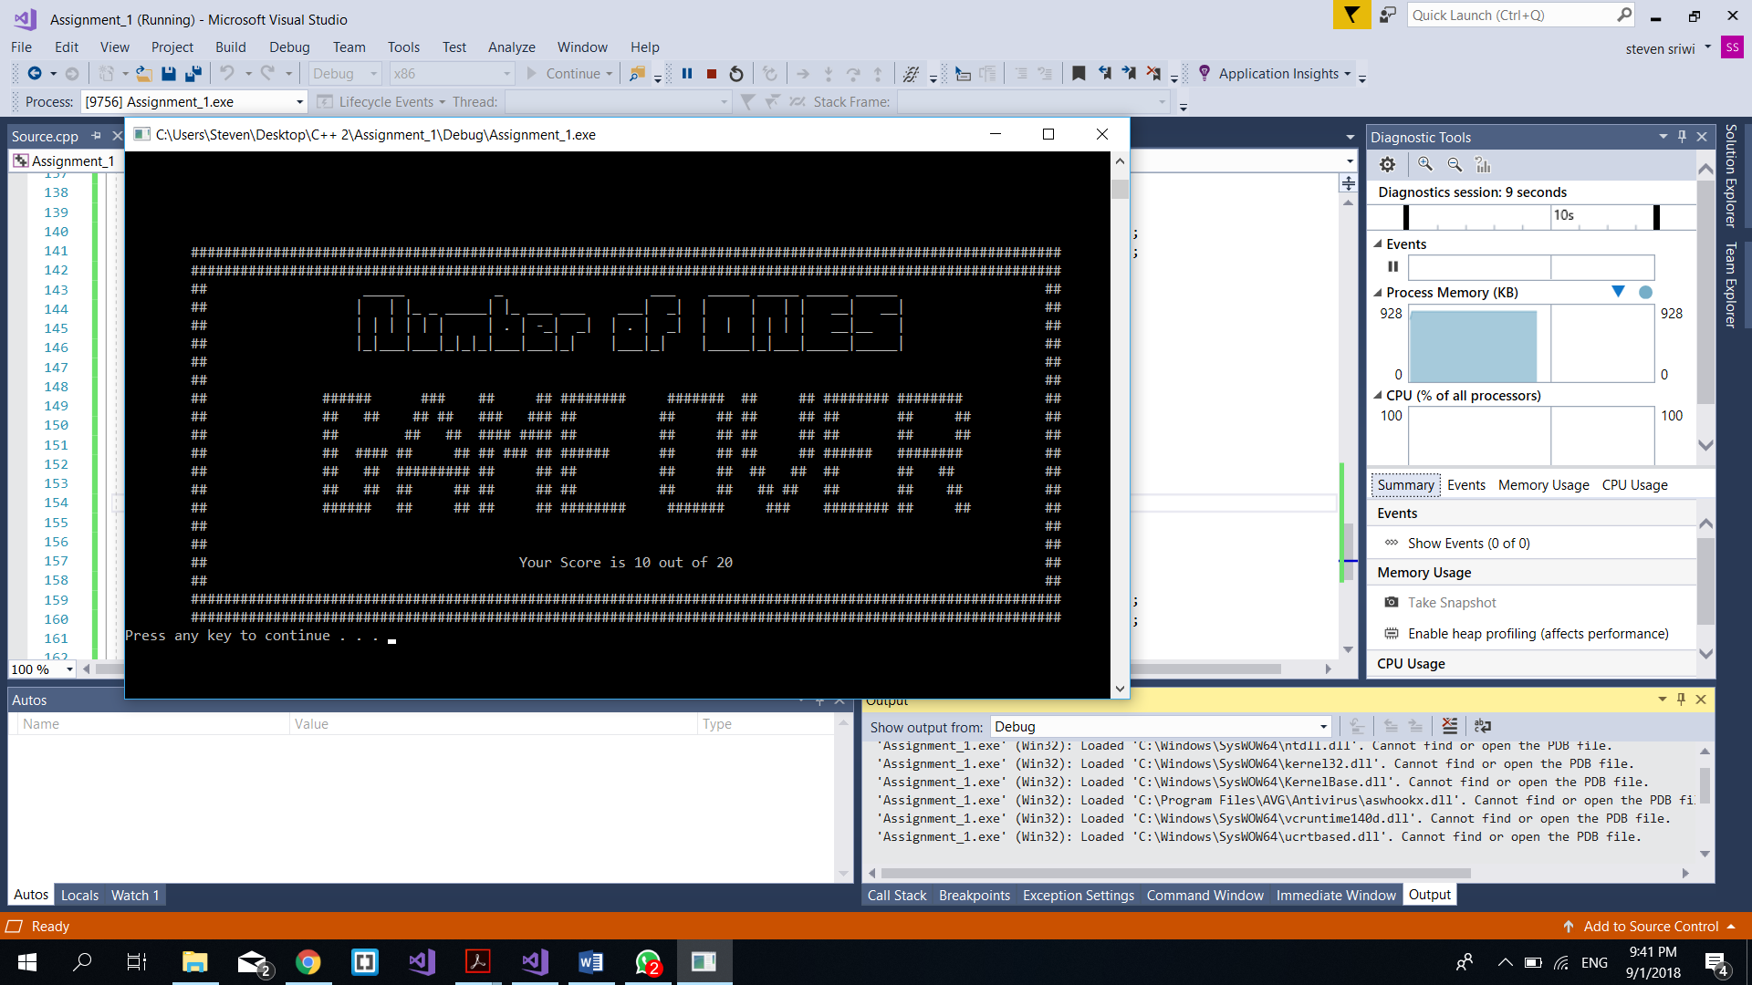

# Classes

## C.Menu

* m_showInstruction() : Is to present the instructions of how to play
* m_loadInstruction() : imports the instruction from the text file (.txt) to the console.
* m_start() : Starts Game.
* m_quit() : Exit program.

## C.Score

* m_win () : shows the result of winning when users wins the game
* m_lose () : shows the result of the high-score when users loses the game
* m_score() : prints the High-score depending on user’s performance.

## C.Number

* m_rand () : Shows to the console the random numbers.
* m_time () : Shows the limit time game.
* m_life() : Shows the number of chances left.

# Project Plan

# Milestone

* Design
  + 1.1 Design summary
  + 1.2 Main Menu Design
  + 1.3 Instruction Page Design
  + 1.4 Game Play Design
  + 1.5 Result Page Design
* 2.0 Content
  + 2.1 Content & Proposal
* 3.0 Development
  + 3.1 Software Coding
    - 3.1.1 Main Menu Page
    - 3.1.2 Instruction Page
    - 3.1.3 Main Game Page
    - 3.1.4 Result Page
    - 3.1.5 Testing
* 4.0 Maintenence & Review
  + 4.1 Teacher's feedback
  + 4.2 Maintenence
  + 4.3 Submission

# Game Flowchart

